YARDBARKER BLOG INSTRUCTIONS
Updated: 9-3-09

Included in this document:

1) Logging in and getting to your blog dashboard

2) Creating a new blog post
Formatting text
Adding hyperlinks
Adding images
Embedding videos
Publishing your post

3) Editing and deleting
Editing/deleting blog posts
Deleting comments on your blog

4) Customizing your blog design
Appearance (colors, fonts, custom header/background images, etc.)
Themes
Widgets (sidebar items)
Links widget (list of links)
Creating new widgets (Twitter, etc.)

5) Blog settings
Blog name and description
Blog category
Blog traffic stats (Google Analytics)

6) Blogging Tips

If you are still having trouble after consulting these instructions, please contact Alana Nguyen at feedback@yardbarker.com.
1) LOGGING IN AND GETTING TO YOUR BLOG DASHBOARD
Go to http://www.yardbarker.com/ and click “Log In” near the top right of the page.
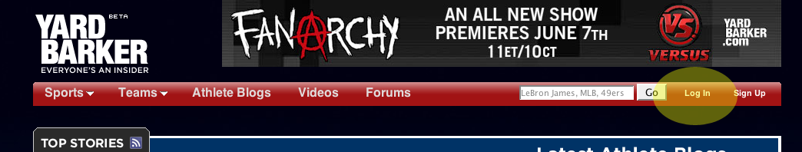

Sign in with your username and password. (If you forget your password, there is an option to have it sent to you if you’ve supplied a valid email address for your account.) Once signed in, click on your username at the top right.

A dropdown menu will appear. Click Blog Dashboard.

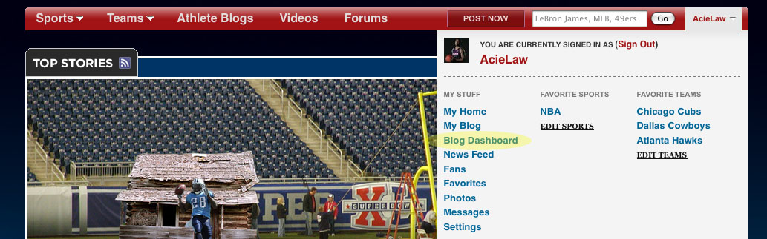

At your blog dashboard, you will see old posts you wrote and options for writing a new post. You can also change your blog design and settings, as described in the following sections.
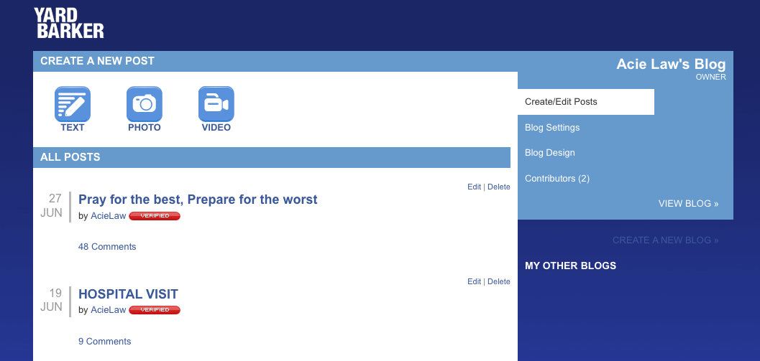
2) CREATING A NEW BLOG POST
On the blog dashboard you have three options for creating a new post: Text, Photo, and Video. The Text button can be used for anything, including a post with multiple photos and videos. If you want to post just one photo or one video, you may find the Photo or Video buttons easier to use. Described here is a post using the Text button.
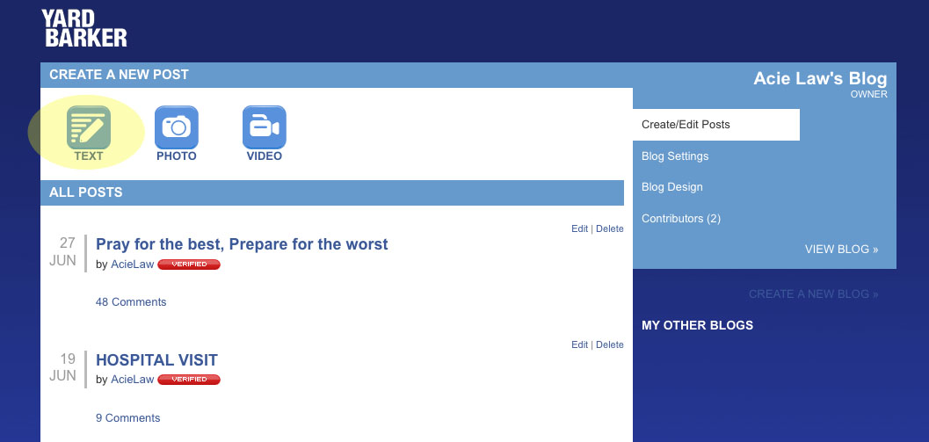
Type the title of the post at the top and then the body of your post in the large text box.
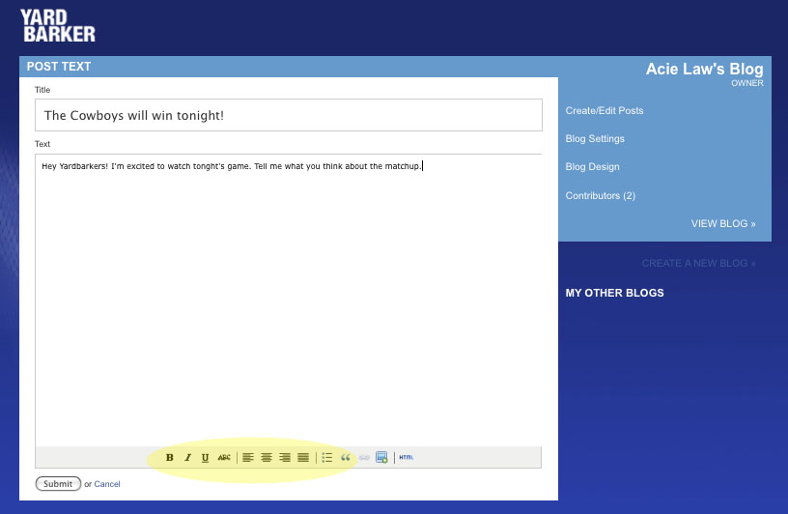

Formatting text. There are formatting buttons at the bottom of the screen. If you highlight a section of your body text, you can use these buttons to make that text bold, italic, underline, strikethrough, aligned left/center/right/justified, bullet listed, or blockquoted.
Adding hyperlinks. If you want to hyperlink a phrase in your body text, highlight that phrase and press the hyperlink button at the bottom of the screen.
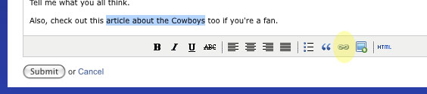
A pop-up window will appear. Type or paste the URL of the webpage you want to use, starting with http://. Then press the Insert button.

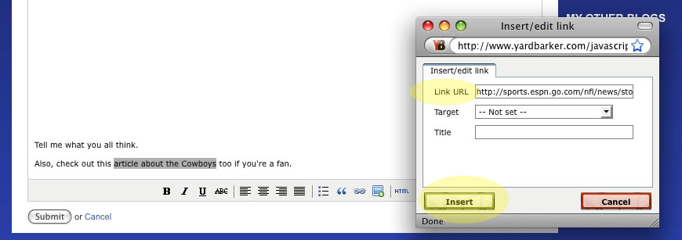

When you’re done, the phrase will appear colored and underlined. After you publish the post, it will be a clickable link.
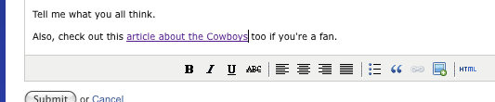

Adding images. You can add multiple images to a post. Press the Image button at the bottom of the screen to add each image one at a time.
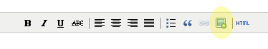
A pop-up window will appear. Press Browse to find the image on your computer. Then press the Upload button.

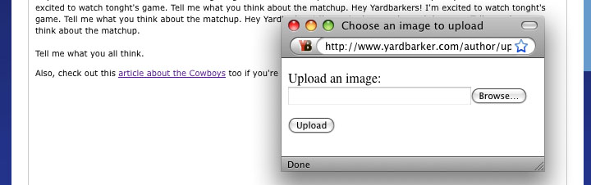

After a few seconds (or longer for slow internet connections), your photo will appear in your text box. If it doesn’t appear, your file size may be too large, or you may be trying to use an invalid file type like a PDF.

You can drag the photo to be anywhere among the text you’ve written. You can also resize the photo to be bigger or smaller by dragging the corner of the photo.

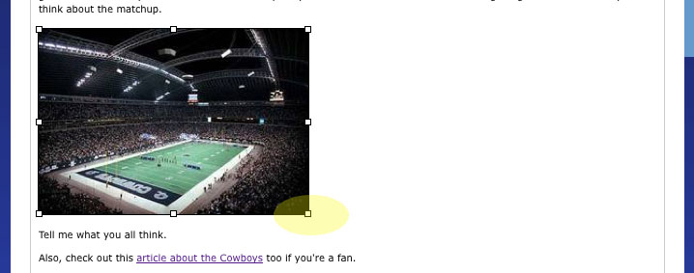
Embedding videos. You can embed multiple videos in a post. First find the “embed code” for the video. Note: this is a string of code, NOT the URL for the webpage where the video is shown. For a YouTube video, you can find the embed code on the right-hand side of the YouTube page.

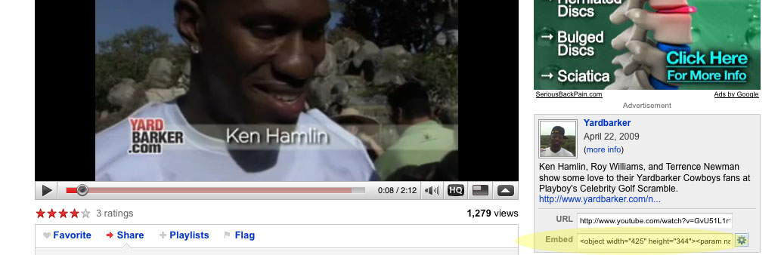
For many videos, there is a button on the player that will give you the embed code.
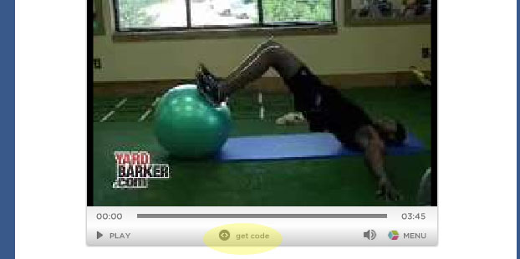
Copy the embed code and then paste it into your post in the place where you want the video to appear. It will just look like code while you are writing the post, but once you publish the post, the video player will appear.

Common video players such as YouTube are supported. If you have a video that won’t embed, you can include a hyperlink instead for readers to click to the webpage where the video plays.
Note: if you edit your post after publishing, you will no longer see the code for the video in your text box, but the video is still there. If you would like to see the code or otherwise edit your HTML, you can use the HTML button.
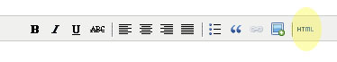
Publishing your post. Once you’re finished, press the Submit button at the bottom of the screen

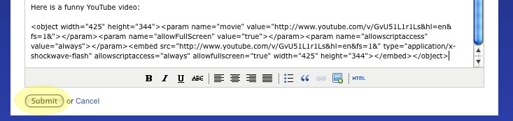
You will be taken to your blog page where you can look at your post. (If you see changes you want to make, you can edit the post, as described in the next section.)
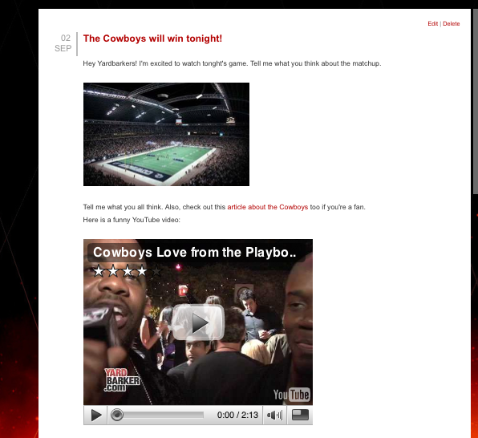
If you want to send the link of your post to friends, Twitter, Facebook, etc, note that there is a unique “permalink” that leads directly to that particular post. The link to your main blog page (such as http://acielaw.yardbarker.com/) will show whatever post is most recent, which will change over time. To get the permalink for a particular post, click on the title of the post from your blog page. The link will be something specific like this: http://acielaw.yardbarker.com/blog/acielaw/Pray_for_the_best_Prepare_for_the_worst/748765

3) EDITING AND DELETING

Editing/deleting blog posts. If you see changes you want to make, you can edit your blog post after publishing.

You can find the Edit and Delete buttons for each post on your blog page (when signed in) or from your blog dashboard.

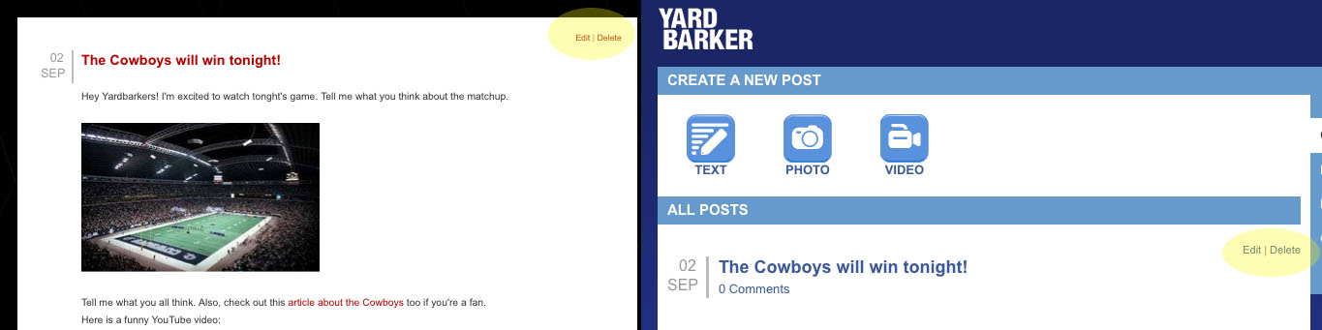

Pressing Edit will take you back to the screen where you created your post. (Note that video embed codes will be invisible, but the videos are still there.)

Pressing Delete will give you a pop-up asking if you’re sure. Please double-check to make sure you are deleting the right post before confirming the delete.

Deleting comments. If you want to delete a comment a user left on your blog post, you can press the Delete button that appears next to the comment (when you are signed in).

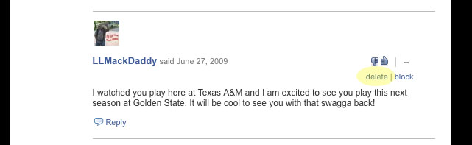
You can also block a user from commenting on your blog in the future by pressing the Block button next to a comment of theirs.
4) CUSTOMIZING YOUR BLOG DESIGN

From your blog dashboard, click the Blog Design tab.
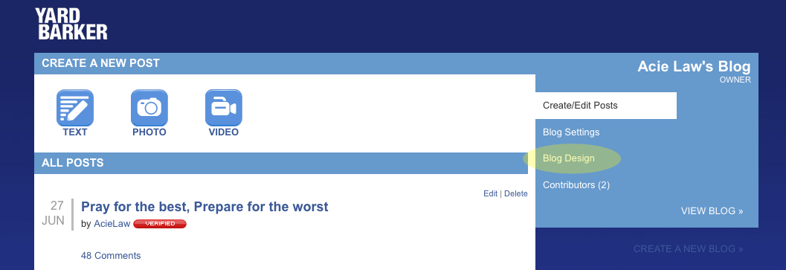

Appearance. You can customize colors, fonts, and various sizing and alignment options. The most common customization option you may want to use is the Images section near the bottom. Here you can upload your own header image (the banner at the top of your blog page) or background image. After making changes, press the Save button at the bottom of the page.

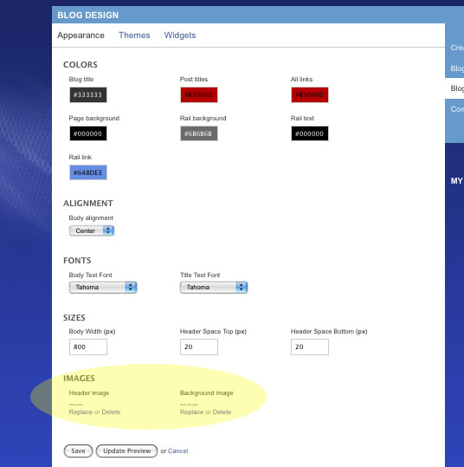
Themes. Instead of customizing your blog on your own as described above, you may prefer to use one of our pre-designed themes. Click on the Themes tab at the top of the Blog Design page.
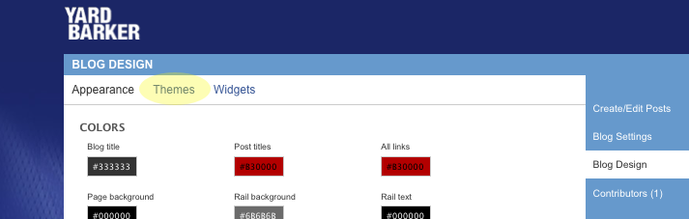

Here you can select a pre-designed skin or theme. Make sure to press the Save button after your selection.
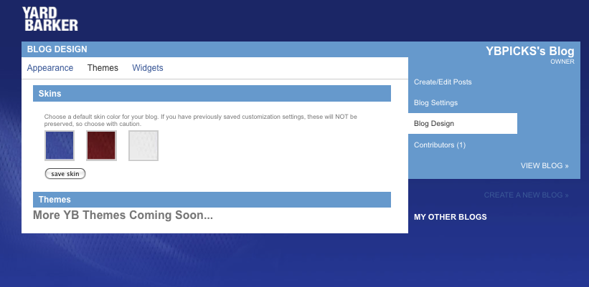
This area is currently under construction and more skins and themes will be added very soon!
Widgets (sidebar items). You can add multiple items to your right-hand sidebar. From the Blog Design page, click to the Widgets tab.
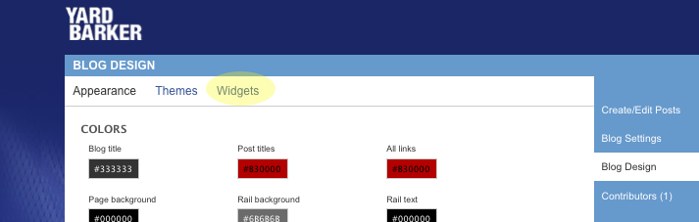
The column on the right shows you the widget items currently active on your blog sidebar. You can change the order they appear in by dragging and dropping the items up and down the list. The widgets on the left are currently not on your sidebar. If you would like to make an unused widget active, click the arrow next to it and it will move to the Active section. To remove a widget from the Active section, click the arrow and it will move to the Unused section.
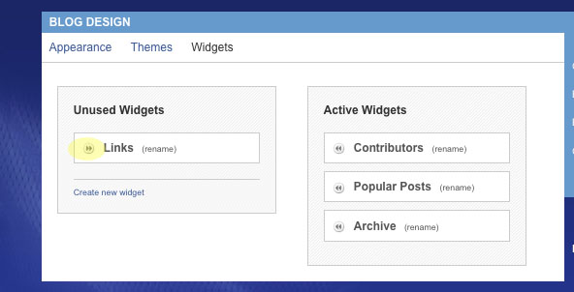
Links widget. If you want to add a list of links to your sidebar, first make sure you have added the pre-designed Links widget to your Active list. Then on your actual blog page, click the Edit button next to the title Links. A button called Add Links will appear. Click on that and fields will appear so that you can type the name of a site and the URL (starting with http://). Press the Add button to add links one at a time.
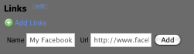
Creating new widgets. You can also create your own widgets. Click the Create New Widget link.

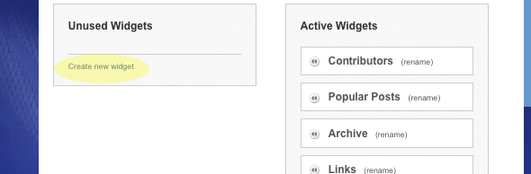

Two fields will appear. In the Name field, type the title that will describe the widget in your sidebar. In the Content field, type the code for the widget. Examples might include embed code for a YouTube video, embed code for a Twitter widget, or simply a paragraph of text. If using embed code, make sure to size the item appropriately for your sidebar.

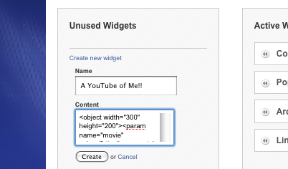
Press the Create button and the widget will appear in your Unused Widget list. To add it to your Active list, click the arrow next to it.
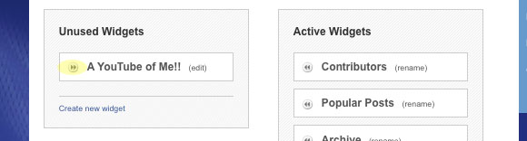
You will now see the widget appearing on your blog sidebar among your other widgets.
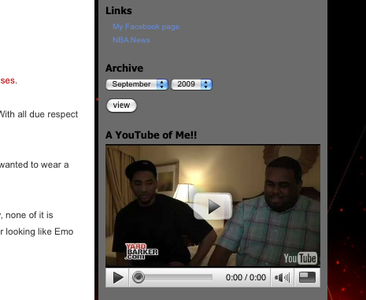
If you need to modify the widget, click the Edit link next to the widget. Note: some of the pre-designed widgets (such as Popular Posts) are not editable. The Links widget is editable on your blog page, as described above.

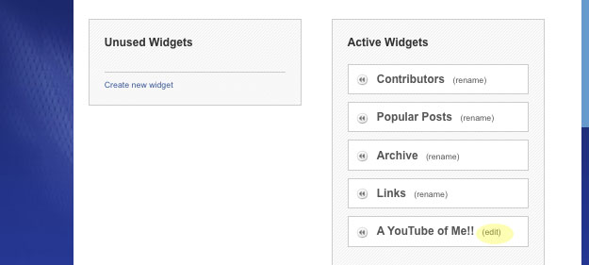
5) BLOG SETTINGS

Blog name and description. Click the Blog Settings tab from your blog dashboard. Add or change the name and description for your blog, then press the Save button at the bottom.

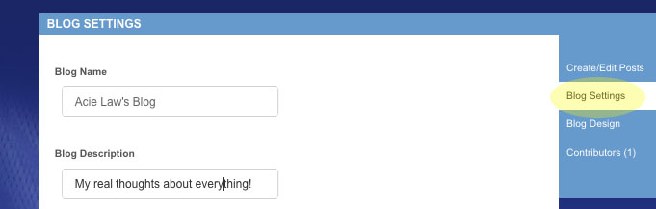

Blog category. Your blog may already be assigned to a sport or team for use on Yardbarker’s sport and team Yards. If you’d like to change your category, click the Change link, choose a sport or team from the dropdowns, and then press the Save button.

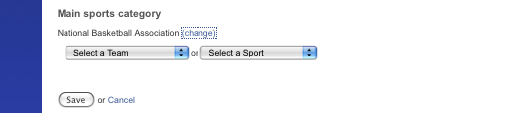

Blog traffic stats. If you’d like to keep track of traffic and related info, you can add Google Analytics to your blog. First sign up for a Google Analytics account here: http://www.google.com/analytics/sign_up.html. Google Analytics will give you an ID code. Add that code to the Blog Settings page and press the Save button.
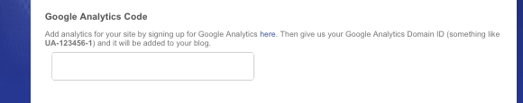

Now when you log into Google Analytics, it will be tracking stats from your Yardbarker blog (this may take a day or more to start working).

6) BLOGGING TIPS

Once you get your blog started, how will you make it popular? Everyone’s formula for success will be different, but you may find some of these tips helpful:

-Post regularly to keep readers coming back.
-Get involved in the blogosphere – read and comment on other sports blogs.
-Offer a unique opinion and NEVER copy someone else’s words for more than a short quote.
-Engage with readers who comment on your blog.
-Link to posts of interest from other bloggers.
-Use promotional tools like Ballhype.com, Digg.com, and Twitter.com.
-Send permalinks of your best posts to other bloggers who might want to link your post, including the Yardbarker editors at pitch@yardbarker.com.

This post by Yardbarker Network blogger Adam Best expands on some of these tips for success:

http://www.yardbarker.com/author/article_external/651503

Good luck and have fun!

